Ethiopia

## Population Data

The data set shows the political stability estimate of the country each year.

## # A tibble: 23 x 5  
## country iso3c date population popCategory5  
## <chr> <chr> <dbl> <dbl> <chr>   
## 1 Ethiopia ETH 1996 58883530 medium   
## 2 Ethiopia ETH 1997 60697443 medium   
## 3 Ethiopia ETH 1998 62507724 medium   
## 4 Ethiopia ETH 1999 64343013 medium   
## 5 Ethiopia ETH 2000 66224804 medium   
## 6 Ethiopia ETH 2001 68159423 medium   
## 7 Ethiopia ETH 2002 70142091 medium   
## 8 Ethiopia ETH 2003 72170584 medium   
## 9 Ethiopia ETH 2004 74239505 medium   
## 10 Ethiopia ETH 2005 76346311 large   
## 11 Ethiopia ETH 2006 78489206 large   
## 12 Ethiopia ETH 2007 80674348 large   
## 13 Ethiopia ETH 2008 82916235 large   
## 14 Ethiopia ETH 2009 85233913 large   
## 15 Ethiopia ETH 2010 87639964 large   
## 16 Ethiopia ETH 2011 90139927 large   
## 17 Ethiopia ETH 2012 92726971 large   
## 18 Ethiopia ETH 2013 95385785 large   
## 19 Ethiopia ETH 2014 98094253 large   
## 20 Ethiopia ETH 2015 100835458 large   
## 21 Ethiopia ETH 2016 103603501 large   
## 22 Ethiopia ETH 2017 106400024 large   
## 23 Ethiopia ETH 2018 109224559 large

# Population growth data

## # A tibble: 23 x 5  
## country iso3c date popGrowth popGrowthCat5   
## <chr> <chr> <dbl> <dbl> <chr>   
## 1 Ethiopia ETH 1996 3.17 high growth rate  
## 2 Ethiopia ETH 1997 3.03 high growth rate  
## 3 Ethiopia ETH 1998 2.94 high growth rate  
## 4 Ethiopia ETH 1999 2.89 high growth rate  
## 5 Ethiopia ETH 2000 2.88 high growth rate  
## 6 Ethiopia ETH 2001 2.88 high growth rate  
## 7 Ethiopia ETH 2002 2.87 high growth rate  
## 8 Ethiopia ETH 2003 2.85 high growth rate  
## 9 Ethiopia ETH 2004 2.83 high growth rate  
## 10 Ethiopia ETH 2005 2.80 high growth rate  
## 11 Ethiopia ETH 2006 2.77 high growth rate  
## 12 Ethiopia ETH 2007 2.75 high growth rate  
## 13 Ethiopia ETH 2008 2.74 high growth rate  
## 14 Ethiopia ETH 2009 2.76 high growth rate  
## 15 Ethiopia ETH 2010 2.78 high growth rate  
## 16 Ethiopia ETH 2011 2.81 high growth rate  
## 17 Ethiopia ETH 2012 2.83 high growth rate  
## 18 Ethiopia ETH 2013 2.83 high growth rate  
## 19 Ethiopia ETH 2014 2.80 high growth rate  
## 20 Ethiopia ETH 2015 2.76 high growth rate  
## 21 Ethiopia ETH 2016 2.71 high growth rate  
## 22 Ethiopia ETH 2017 2.66 high growth rate  
## 23 Ethiopia ETH 2018 2.62 high growth rate

## Population trend

The plot shows the population trend of the country.

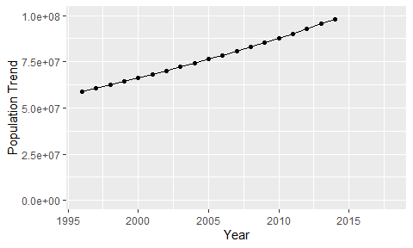

Political Stability Trend

# Population growth trend

The plot shows the population growth rate trend of the country.

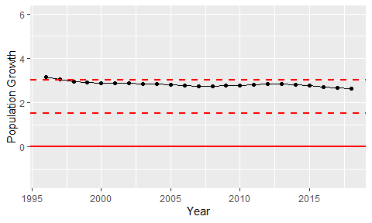

Population Growth Trend